Prep:
- Confirm contents of wagon:
  - Cord bag
  - Printer
  - Extra paper and ink
  - Camera and stand
  - Computer
  - Controller
  - Tablecloth and non-slip mat
- Screen
- If a hotspot or confirmed available wifi at install location is available, do on site
  - Pull from github (plug in demo computer and into monitor)
  - Github desktop – Fetch Origin, then Pull Changes (at top)
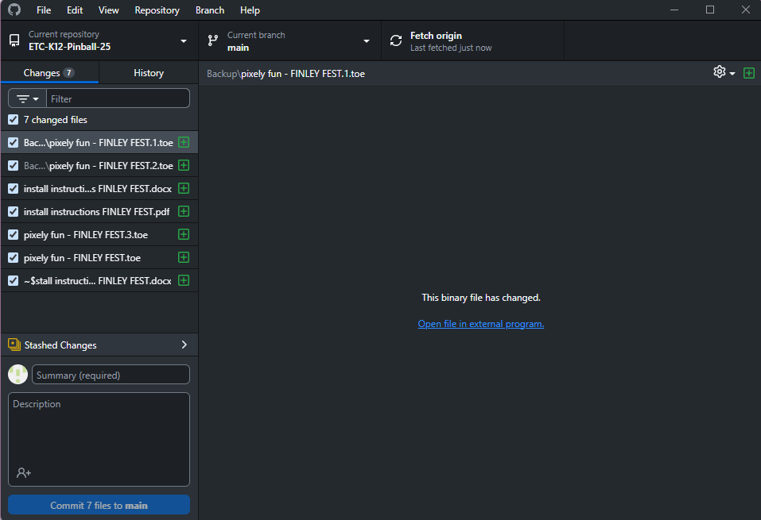
On Site Install:
- Plug everything in
  - Screen
  - Computer
  - Printer (power and usb)
  - Mouse
  - Keyboard
  - Camera
- Log in
  - User: demo
  - Password: etcdemo123
- For ease of setup, right click on taskbar (bottom bar with icons) head to taskbar settings. Under taskbar behavior uncheck automatically hide taskbar.
- (note about sound?)
- Pull from Github (see #3, if not already done)
- Turn off wifi, (accidentally connecting can mess up NDI connection)
- Open unity hub and open Unity_Project (*AV add file path for if it gets removed)
- open TouchDesigner (TD) file: pixely fun - FINLEY FEST.toe (in main github repo, see #8) (*AV update file ext)
- Open the Unity Editor, navigate to Photo Camera Manager (below right), in inspector panel, switch to ETC-PINBALL-02 (TouchDesigner) (*AV replace pic)
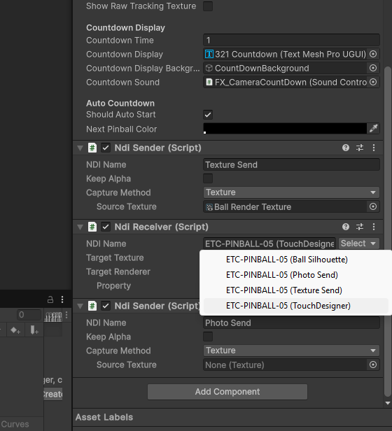
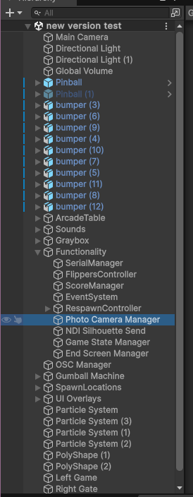

- Play scene (ctrl + p), go through screens, launch a few balls and switch back to TD

- Nav to TD
- Put all windows to as follows, (*AV update pics 02 instead of 05)
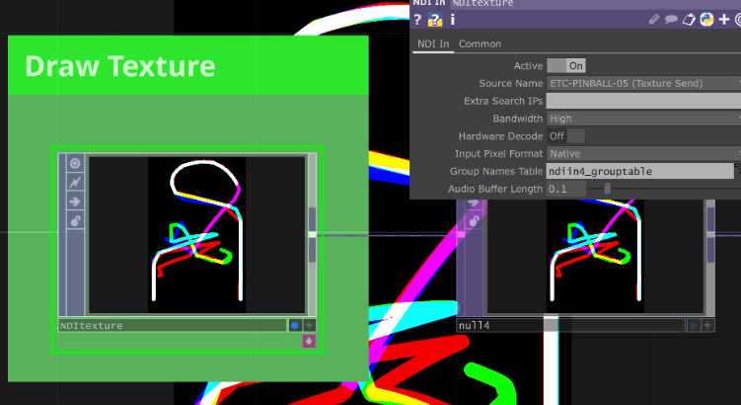
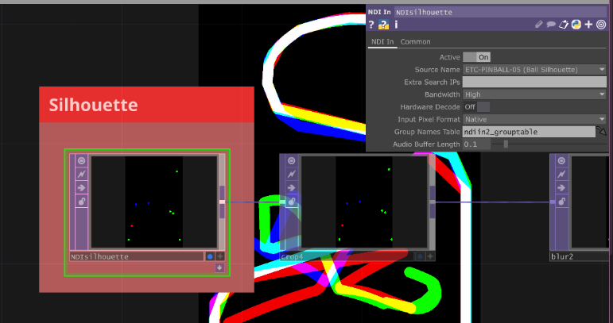

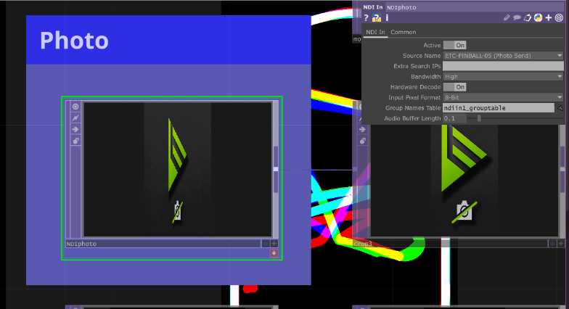

- Ensure that this photo is selected for moviefilein3 (towards right, before print tile) (*AV update with colored border)
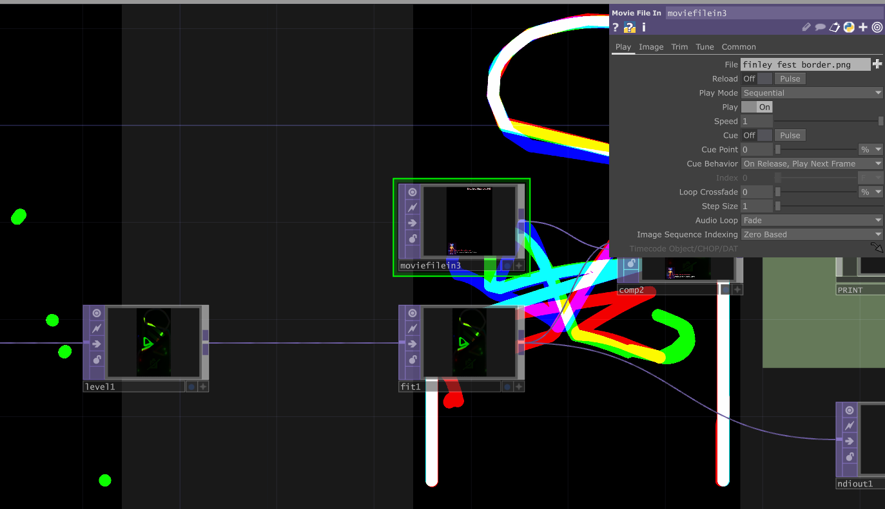
- If not, double click file name and open border FINLEY FEST.png

- Final adjustments:
  - Ensure playmode tint is black; it should look like this:
  - If not, stop playing (ctrl+p), navigate to Edit > Preferences> colors, scroll to playmode tint and select black (insert pic)
- Hide taskbar (see #6, check box)

Troubleshooting:
- First, go back through the list and double check:
  - Is everything plugged in?
  - Are all NDI points correctly selected?
  - Is wifi turned off?
- If ball tracking isn’t live on the gameboard:
- If it is not printing:
- If controller isn’t registering

